**Module00 SOLID Principle**

**Notes:-**

**Clean architecture: - it’s the structure that hold the main part**

**Domain: which hold the entity layer**

**Application: which hold the business login layer**

**Infrastructure: which hold the access and call with the database**

**Presentation: which hold the API’s which hold the API definitions**

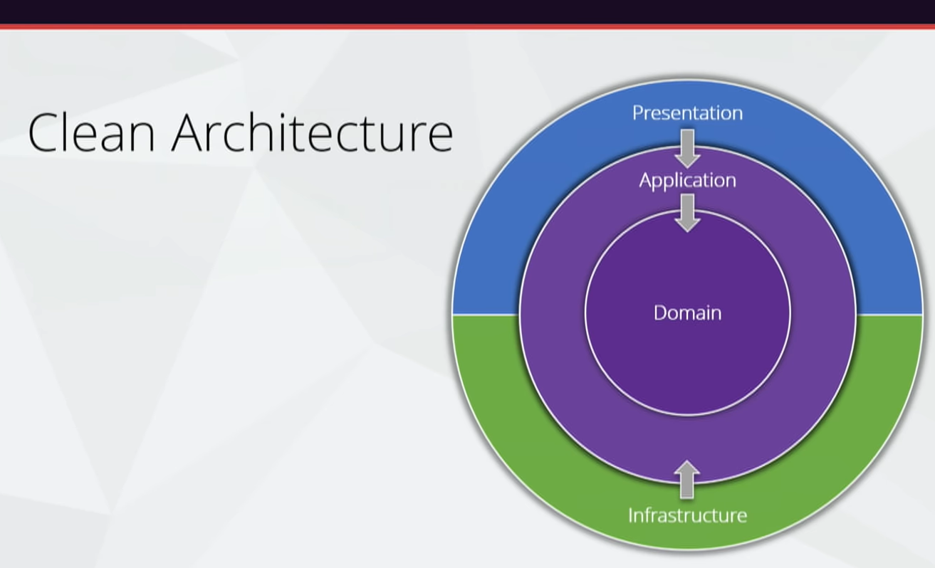

**If you want to apply repository pattern on your application I will make the interface on application layer and the implementation on the infrastructure layer**

**(We see there is the domain layer has no dependencies on other layers)**

**(We have to make sure that the logic stay on Domain layer only not on other layer, infra used to call with database not more and the application communicate with the presentation layer not more)**

**(By this approach we make isolation the business logic inside 1 layer called Domain and can by integrate with other system without any dependencies)**

**Advantages**

**1-Independent of frameworks**

**2-testable (since all logic exist only on 1 layer called Domain Layer)**

**3-Independent of UI**

**4-Independent of database (you can switch to any database)**

**5-Independent anything external**

**Idea of the begin of clean architecture**



